Case 4-Xian-Byzantine-Plaque-OAO 600-1000 CE

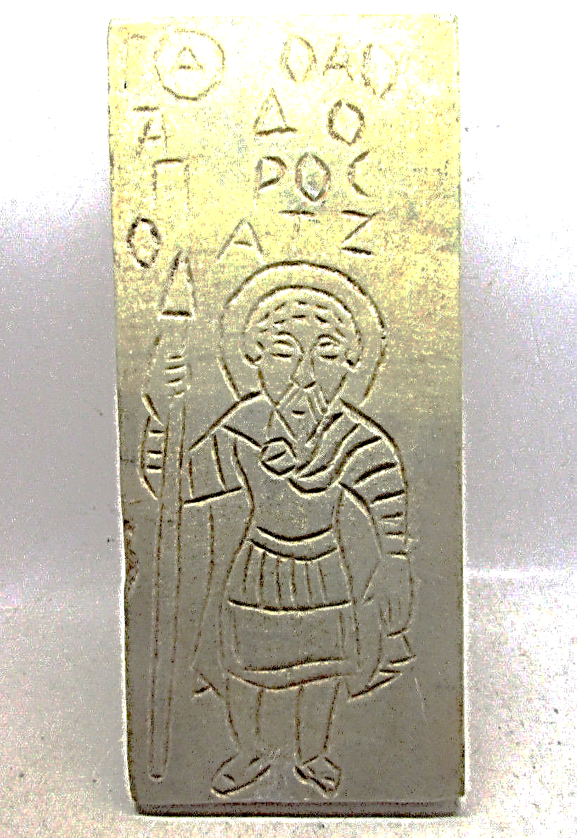

CIRCA 600-1000 CE BYZANTINE ERA HAND CRAFTED STONE PANEL WITH SAINT & INSCRIPTION